Department of Pharmaceutical Microbiology
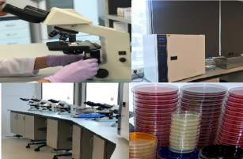

The Department of Pharmaceutical Microbiology at the Department of Basic Pharmaceutical Sciences, Faculty of Pharmacy, Fenerbahçe University, studies the structure and properties of microorganisms that cause diseases in humans and the microbiological methods used to diagnose these diseases. It also covers the production, quality control, and use of antimicrobial agents and microbial-derived products, as well as sterilization and disinfection methods and general hygiene. Our department aims to produce graduates who understand the basic concepts of pharmaceutical microbiology, which is a multidisciplinary sub-branch of microbiology, and who can use this knowledge effectively in all areas of their profession.

Research Areas:
Classification of microorganisms
Production of microorganisms
Identification of microorganisms
Antibiotic susceptibility testing
Mechanisms of action of antibiotics
Serological and immunological tests
Infections
Disinfection and sterilization

