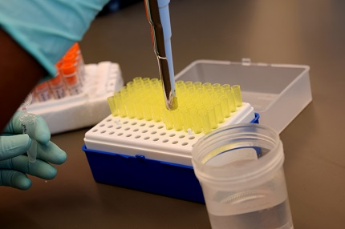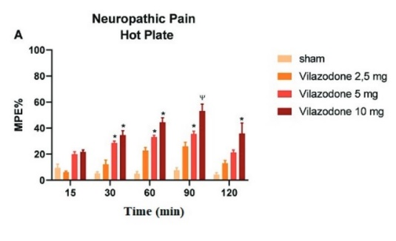

Pharmacology is the study of the interactions that occur between a living organism and chemicals that affect normal or abnormal biochemical function.
The two main areas of pharmacology are pharmacodynamics and pharmacokinetics. Pharmacodynamics studies the effects of a drug on biological systems, and pharmacokinetics studies the effects of biological systems on a drug. In broad terms, Pharmacodynamics is the study of the biochemical and physiological effects of drugs and their mechanisms of action which mainly involve interaction with macromolecular components termed receptors, while pharmacokinetics discusses the absorption, distribution, metabolism, and excretion (ADME) of chemicals from the biological systems.
Research areas:
Preclinical studies
Deciding whether a drug is ready for clinical trials involves extensive preclinical studies that yield preliminary efficacy, toxicity, pharmacokinetic and safety information. Wide doses of the drug are tested using in vitro (test tube or cell culture) and in vivo (animal) experiments.
Clinical studies
For drug development, the clinical phases start with testing for drug safety in a few human subjects, then expand to many study participants (potentially tens of thousands) to determine if the treatment is effective. If the drug successfully passes through the first 3 phases I, II, and III, it will usually be approved by the national regulatory authority for use in the general population. Phase IV trials are 'post-marketing' or 'surveillance' studies conducted to check the drug's performance in real life scenarios, to study the long-term risks and benefits of using the drug and to discover any rare side effects.

