DEPARTMENT OF PHARMACY TECHNOLOGIES
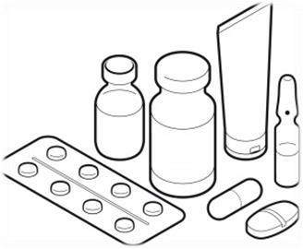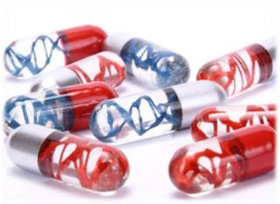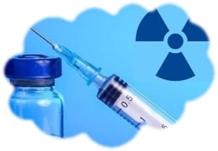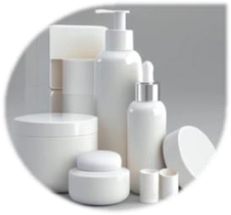

Pharmacy Technology part of the Pharmacy curriculum includes Pharmaceutical Technology, Pharmaceutical Biotechnology, Radiopharmacy and Cosmeticology.

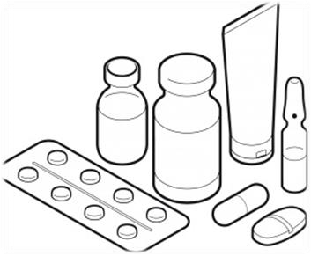
Pharmaceutical Technology is concerned with the scientific and technological aspects of the design and manufacture of dosage forms and drug delivery systems. Examples of traditional drug dosage forms are solutions, suspensions, emulsions, injectables, gels, ointments, creams, pastes, suppositories, powder, granules, capsules, tablets etc. Modern drug delivery systems include controlled drug release systems (e.g., transdermal patches, ophthalmic inserts, osmotic pumps etc), particulate systems (micro-, nano-spheres/capsules), vesicular systems (liposome, niosomes etc), and drug delivery techniques (nebulizer, iontophoresis, phonophoresis, intra-uterine devices, micro-needles, insulin pump, patient-controlled analgesia-PCA-pump etc).
Successful formulation of dosage forms follows a systematic research and development stage wherein active drug substance and different excipients are mixed and processed checking out their compatibility. Their chemical, physical and microbiological stability are also ensured through stability testing program. Dosage forms can be prepared on a small scale based on physicians’ prescription for individual patients (magistral /compounding) or on a large/industrial scale for distribution and sales through pharmacies and hospitals. To ensure the safety, efficacy and quality, medicines are produced under strict Good Manufacturing/Compounding Practices.
All the above aspects are covered through several theoretical and practical courses in the Pharmacy curriculum. These are PHAR2006 Pharmaceutical Technology-I, PHAR2008 Pharmaceutical Technology I Laboratory (4th semester), PHAR3005 Pharmaceutical Technology II, PHAR3007 Pharmaceutical Technology II Laboratory (5th Semester), PHAR3004 Pharmaceutical Technology III, PHAR3006 Pharmaceutical Technology III Laboratory (6th Semester) and PHAR5005 Pharmaceutical Quality Management (9th semester). Some more related courses are also offered in the 9th semesters as elective courses.
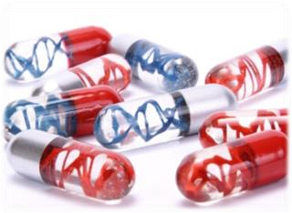
Biotechnology uses biological systems (eg, cell, tissue), living organisms, or their derivatives (eg, enzyme), to make or modify products or processes for specific usage. Pharmaceutical Biotechnology focuses on biotechnology of pharmaceutical relevance. In contrast to small molecule chemical drugs, biotechnology-derived drugs are large molecule drugs, either protein or nucleic acid in nature. PHAR4008 Pharmaceutical Biotechnology (8th semester) course covers related basic concepts, recombinant DNA technology, hybridoma technology, anti-sense technology, gene therapy, vaccine, and down-stream production, formulation and manufacturing of dosage forms.

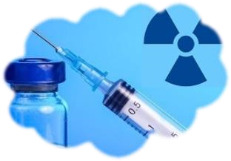
Radiopharmaceuticals are drug which emits radiation and are used as a diagnostic or therapeutic agent. Radiopharmacy, also known as Nuclear Pharmacy, involves preparation of radioactive materials for patient administration. This is a regulated by multiple regulators and legislation, because this involves occupational exposure of staff to ionizing radiation, preparation of medicines, patient exposure to ionizing radiation, transport
of radioactive materials, and environmental exposure to ionizing radiation. Radiopharmacy is covered in the pharmacy curriculum by elective courses offered in the 9th semester.

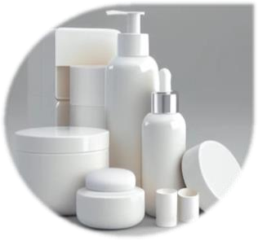
Cosmetics are substances or mixture intended to be placed in contact with the external parts of the human body (epidermis, hair system, nails, lips and external genital organs) or with the teeth and the mucous membranes of the oral cavity with a view exclusively or mainly to cleaning, protecting, keeping in good condition, changing appearance, perfuming, or correcting body odors. Cosmeticology is concerned with the design and manufacturing of cosmetic products. PHAR4009 Cosmeticology (7th semester) covers systematic classification of cosmetic products,
cosmeceuticals and innovative cosmetic delivery systems, their desired characteristics, safety and efficacy, manufacturing, licensing and regulatory affairs.

Research Interest
•

Molecular
pharmaceutics

•

Pre
-
formulation

•

Formulation

•

Innovative
d
rug delivery systems

•

Industrial Produc
tion

•

Up
-
stream and down
-
stream processing
of

b
iopharmaceuticals

•

Radiopharmaceuticals

•

Cosme
ceuticals and c
osmetic delivery systems

•

Quality Assurance
,
QbD
,

PAT

