PAYMENT METHODS
Payment via Bank Transfer/EFT
For national students:
- The full tuition fee for the summer school must be deposited via Bank transfer/EFT to our university's IBAN number provided below.
RECIPIENT NAME: | FENERBAHÇE ÜNİVERSİTESİ
BANK NAME: | TÜRKİYE EKONOMİ BANKASI
IBAN: | TR81 0003 2000 0000 0102 6362 00
EMAIL: | finans@fbu.edu.tr
DESCRIPTION: | Student Number + Student Name Summer School Tuition Fee

Payment via Credit Card
For national students:
- The full tuition fee for the summer school can be paid via single installment credit card payment through our university's online payment system provided below.
For international students:
International students can pay the summer school fees to our university's USD accounts via Bank transfer/EFT as indicated below.
RECIPIENT NAME: | FENERBAHÇE ÜNİVERSİTESİ
BANK NAME: | VAKIFBANK
IBAN: | TR74 0001 5001 5804 8023 7883 62
SWİFT | TVBATR2A
DESCRIPTION: | Student Number + Student Name Summer School Tuition Fee

RECIPIENT NAME: | FENERBAHÇE ÜNİVERSİTESİ
BANK NAME: | GARANTİ BANKASI
IBAN: | TR79 0006 2001 6080 0009 0979 10
SWİFT | TGBATRIS
DESCRIPTION: | Student Number + Student Name Summer School Tuition Fee

Payment via Credit Card For international students:
- The full tuition fee for the summer school can be paid via single installment credit card payment through our university's online payment system provided below.

*** IMPORTANT NOTE: Cash payments and physical credit card payments will not be accepte
Online Payment Steps (Detailed Explanation):
To make an online payment:
1. Visit https://unisis.fbu.edu.tr
2. Log in with your student email address and password on the screen that appears.
*Below is an example of the transaction steps with a sample student.
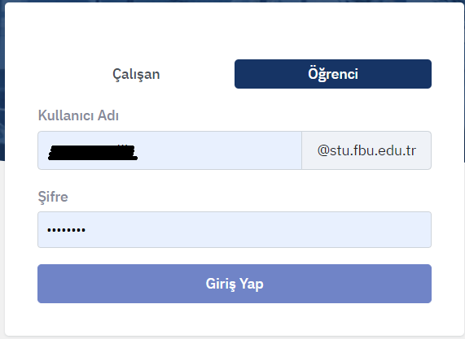

4. After logging in, click on the "ÖDEME EKLE" button to make a payment with a credit card on the screen that appears.
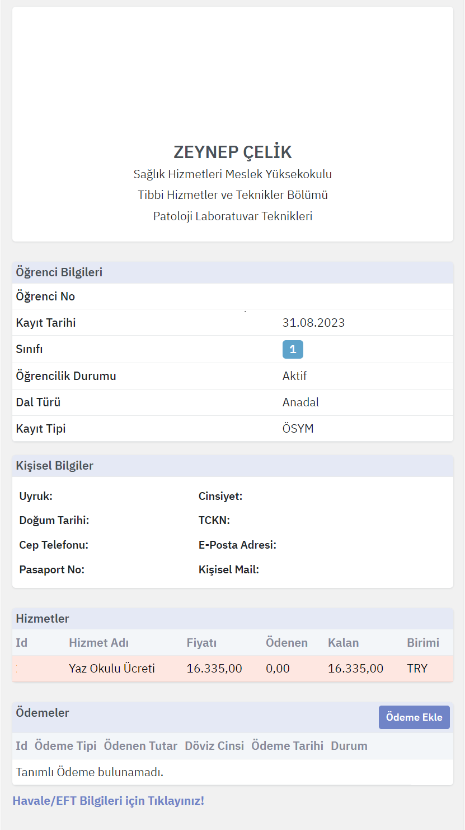

*When you click on the "ÖDEME EKLE" button, the amount to be paid will automatically appear on the screen. Click the "TAMAM" button afterwards.
*After clicking the "TAMAM" button, the system will redirect you to the credit card payment screen, where you can enter your credit card/bank card information and complete the payment.
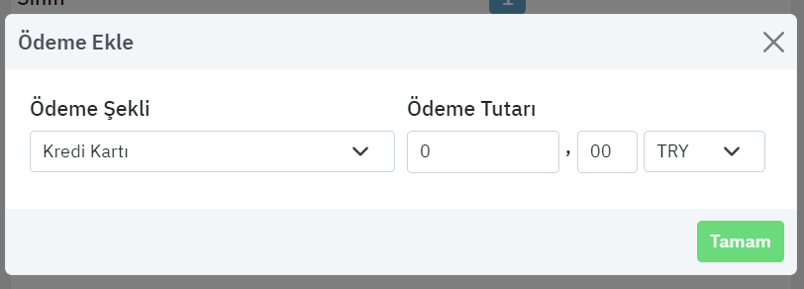
* To make payments via Bank transfer/EFT to bank accounts, click on the "HAVALE/EFT Bilgileri için Tıklayınız" button. You can make your payment to the bank accounts shown on the screen that opens.
