Summer School Course Selection Guide
- When you log in with your username and password at https://ois.fbu.edu.tr , you will access the following page from the link labeled under the "Course Transactions" menu, which can be reached via the icon.
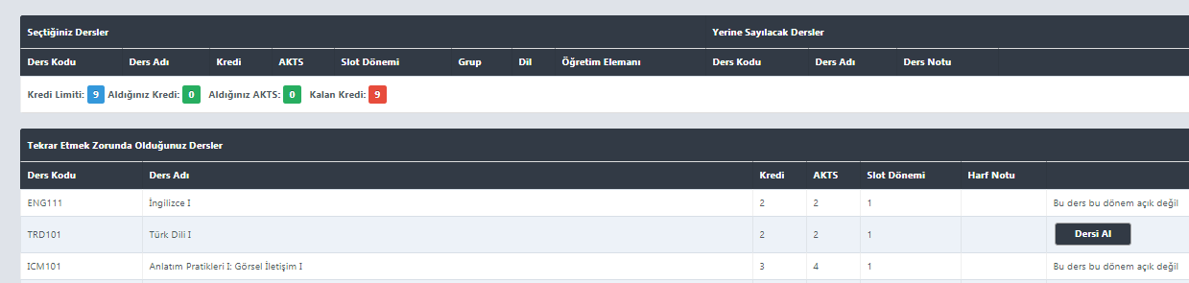

- By clicking on the button next to the course(s) you want to select, you will complete the first step of the course selection process.
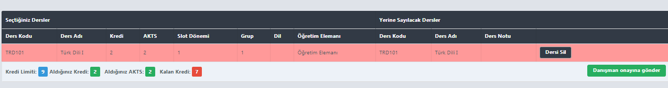

- The selected course(s) will appear in the "Seçilen Dersler" section. Then, by clicking on the button, you will submit the selected course(s) for advisor approval.

- After your course registration is approved by your advisor, you can proceed with your payment. Once you've made the payment, your course selection will be confirmed, and the courses you've taken will be reflected in your transcript.

