Summer School Course Selection Guide for Students from other Universities

- Please visit https://ois.fbu.edu.tr/basvurular/kurumdisiyazokulu and log in the system via using your Turkish ID number and mobile phone number. Then click the "Başvuru Yap" button.
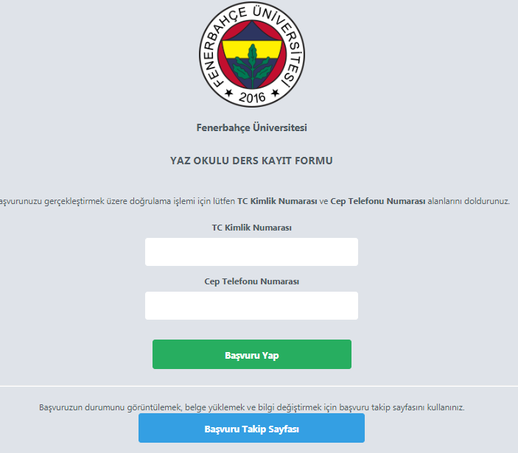
- After you click on the “Başvuru Yap” button, you will receive a verification code via SMS. Please enter the code to “Doğrulama Kodu” area. Then click on the “ Devam Et” button.
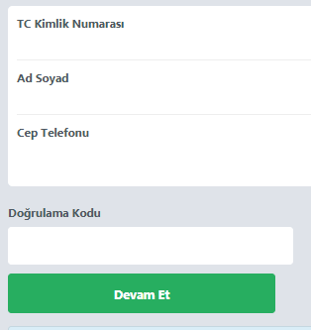

- Please provide the necessary information then click on the “ Devam Et” button.
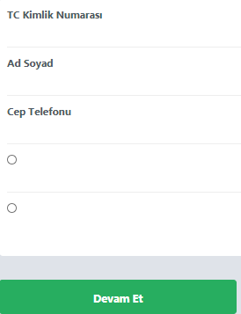
- Please upload the copy of your ID and the proof of your home institution approval. Choose the course(s) you want to select and please click on “Ekle” button. After you complete your course selection, please click on the “Başvuru Yap” button.
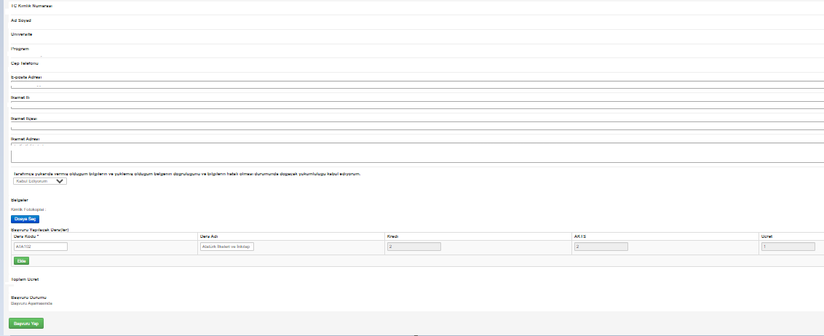

- When you click on the “başvuru yap” button, pin code information will be sent to the e-mail address you entered in Step 1. After completing your payment within the fee information specified in Step 1, log in with your ID number sent to the application tracking page below and the pin code sent previously.
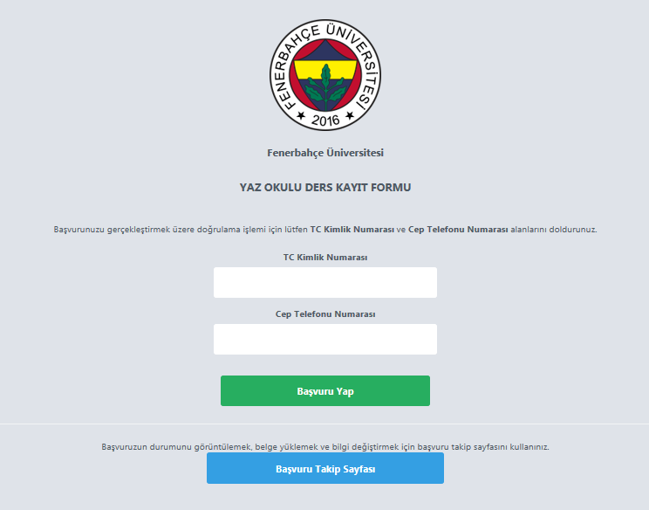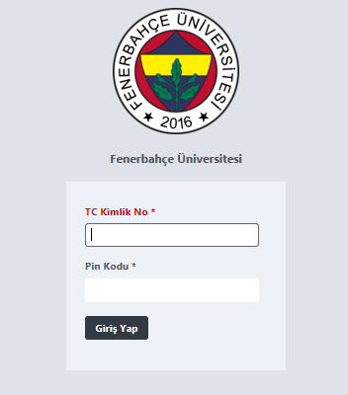
- After logging in to the application tracking screen, upload your payment receipt and click on the “Ödeme Bildirimi Yap” button. Your course schedule will then be sent to you via e-mail.

